

**ALAGAPPA COLLEGE OF TECHNOLOGY**

**ANNA UNIVERSITY-600025**

**NM Assignment / Digital Marketing**

|  |  |  |
| --- | --- | --- |
| NAME | REG.NO | Naan Mudhalvan ID |
| SANGAMITHRA S R | 2020308028 | 1D6803FE0D54CFCA419414EB865CB4B2 |

**1. Create a blog or website using Blogpost Customize the theme design and post new article with 500 words.**

https://foodatbigbite.blogspot.com/2023/10/south-indian-cuisines-that-are-must-try.html?m=1

**2. Create a New Facebook Business Page and post one social media poster for your brand.**

https://www.facebook.com/profile.php?id=61553012000713&mibextid=ZbWKwL

**3. Create and design a social media advertisement poster using canva.**

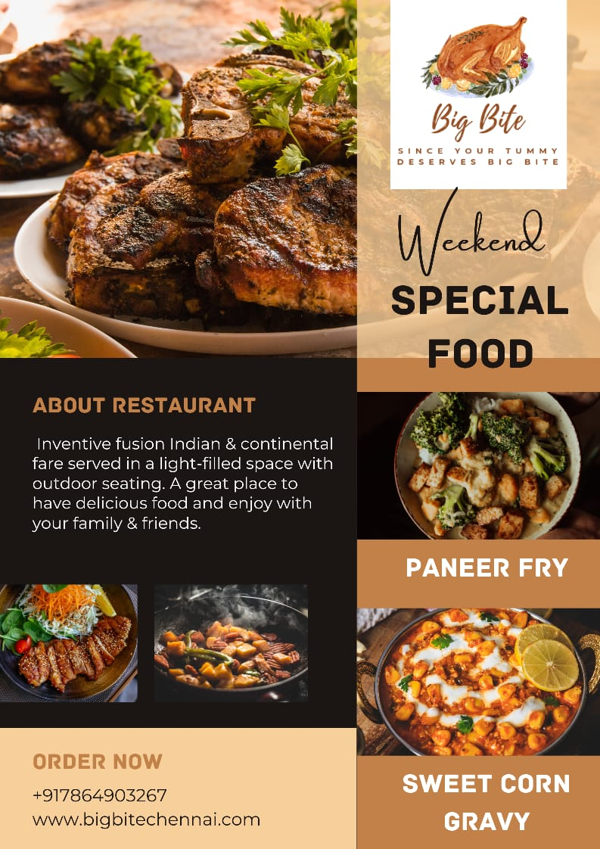

**4. Create email newsletter design using MailChimp or canva tool**.

